Form utama

Form utama digunakan sebagai form pertama yang di tampilkan menjadi form menu bagi aplikasi ini. Form utama terdiri dari semua menu yang akan ditampilkan dalam aplikasi ini.

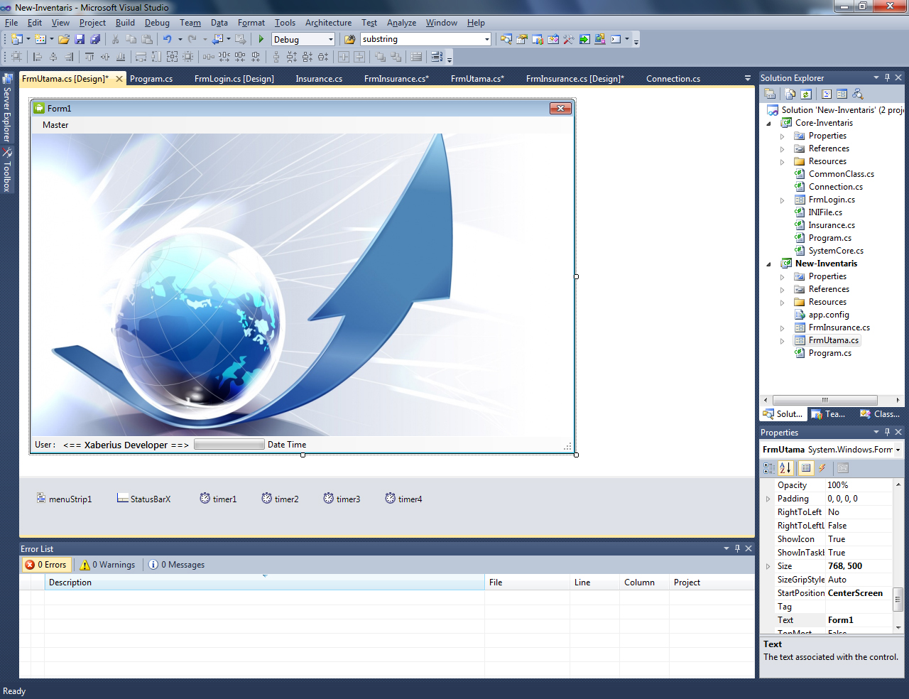

Component yang digunakan

1. Form 1 buah.
2. Menu strip 1 buah.
3. Gambar utama.
4. Status strip 1 buah.
5. Timer 4 buah.

Codinnya :

using System;

using System.Collections.Generic;

using System.ComponentModel;

using System.Data;

using System.Drawing;

using System.Linq;

using System.Text;

using System.Windows.Forms;

using Core_Inventaris;

using MySql.Data.MySqlClient;

namespace New_Inventaris

{

public partial class FrmUtama : Form

{

// variable definition

Connection Connection = new Connection();

SystemCore SystemCore =new SystemCore();

Insurance Insurance = new Insurance();

private int X = 0;

public FrmUtama()

{

InitializeComponent();

}

private void genuineCheck()

{

if (!SystemCore.readSerialHardware())

{

MessageBox.Show("Aplication error please reinstall this program", "Critical Error.",

MessageBoxButtons.OK, MessageBoxIcon.Error);

this.Close();

}

}

private void FrmUtama_Load(object sender, EventArgs e)

{

List<string> Database = Connection.readSever();

//trying to connect to database server

try

{

Connection.connection(Database[0], Database[1], Database[2]);

}

catch (Exception ex)

{

MessageBox.Show("Database disconnect. Please contact your administrator.", "Database",

MessageBoxButtons.OK, MessageBoxIcon.Error);

this.Close();

Console.WriteLine(ex.Message);

}

genuineCheck();

//setting status bar

toolStripStatusLabel2.Text = "";

toolStripProgressBar1.AutoSize = false;

toolStripStatusLabel1.AutoSize = false;

toolStripStatusLabel2.AutoSize = false;

toolStripStatusLabel3.AutoSize = false;

toolStripProgressBar1.Width = (StatusBarX.Width / 5) + 49;

toolStripStatusLabel1.Width = (StatusBarX.Width / 4) - 69;

toolStripStatusLabel2.Width = (StatusBarX.Width / 4) + 69;

toolStripStatusLabel3.Width = (StatusBarX.Width / 4);

}

private void timer1_Tick(object sender, EventArgs e)

{

//running text

string Merk = " <== Xaberius Developer ==> ";

toolStripStatusLabel2.Text = toolStripStatusLabel2.Text + Merk[X];

this.X++;

if (this.X == Merk.Length)

{

this.X = 0;

}

}

private void timer2_Tick(object sender, EventArgs e)

{

toolStripStatusLabel3.Text = DateTime.Now.ToString();

}

private void timer3_Tick(object sender, EventArgs e)

{

if (toolStripProgressBar1.Value < toolStripProgressBar1.Maximum)

{

toolStripProgressBar1.Value = toolStripProgressBar1.Value + 1;

}

else

{

timer3.Enabled = false;

timer4.Enabled = true;

}

}

private void timer4_Tick(object sender, EventArgs e)

{

if (toolStripProgressBar1.Value > toolStripProgressBar1.Minimum)

{

toolStripProgressBar1.Value = toolStripProgressBar1.Value - 1;

}

else

{

timer3.Enabled = true;

timer4.Enabled = false;

}

}

private void carInsuranceToolStripMenuItem_Click(object sender, EventArgs e)

{

//open insurance menu

FrmInsurance FrmIns= new FrmInsurance();

FrmIns.Show();

}

}

}